

**LAPTOP REQUEST CATALOG ITEM**

**Project Overview:**

At ABC Corporation, employees frequently require laptops to perform their work effectively. However, the current laptop request process is manual, time-consuming, and prone to errors, often resulting in delays and incomplete data collection. This creates inefficiencies for both employees and IT support teams.

This project introduces a **Laptop Request Catalog Item** within ServiceNow to streamline and automate the laptop request process. By incorporating dynamic fields, clear instructions, and form reset functionality, the catalog item ensures that users have a guided, error-free, and efficient request experience. Additionally, all changes and configurations will be tracked to support governance and deployment best practices.

By implementing this solution, ABC Corporation aims to:

* Eliminate delays caused by manual handling of laptop requests
* Ensure accurate data collection through dynamic form behavior
* Enhance employee satisfaction with a modern and user-friendly request interface
* Improve IT efficiency by standardizing and automating request fulfillment
* Strengthen governance through proper tracking of changes and deployments

Ultimately, this initiative supports the organization’s goal of improving service delivery and providing employees with the right tools quickly and efficiently, enabling them to stay productive and focused on their work.

## Table of Contents

1. Introduction
2. Project Objectives
3. Key Features
4. ServiceNow Developer Setup
5. Project Implementation in ServiceNow
6. Screenshots of Output
7. Conclusion

## **1. Introduction**

In today’s digital workplace, employees rely heavily on having the right devices to perform their tasks efficiently. At ABC Corporation, the process of requesting laptops is currently manual, time-consuming, and prone to delays or incomplete submissions. This not only affects employee productivity but also places additional strain on IT support teams responsible for handling requests.

To address these challenges, this project focuses on implementing a **Laptop Request Catalog Item** within ServiceNow. By leveraging dynamic form behavior, clear instructions, and workflow automation, the catalog item will provide employees with a guided and user-friendly interface to submit laptop requests. This ensures that accurate information is captured from the start, reducing errors, improving processing speed, and delivering a more seamless request experience.

## **2. Project Objective**

The primary objective of this project is to implement a **Laptop Request Catalog Item** within ServiceNow that simplifies and accelerates the process of requesting laptops at ABC Corporation. The solution is designed to:

* Automate and standardize the laptop request process to eliminate manual errors and delays.
* Provide dynamic form behavior to guide users and ensure accurate data collection.
* Enhance the user experience with clear instructions, intuitive design, and form reset functionality.
* Improve IT efficiency by streamlining request handling and fulfillment workflows.
* Strengthen governance and compliance through proper tracking of changes and deployment.

By achieving these objectives, the project aims to deliver a modern, efficient, and employee-centric request process that supports both productivity and service excellence across the organization.

## **3. Key Features**

• **Dynamic Form Behavior** – Fields adapt based on user selections (e.g., laptop type, usage needs, or department).

• **Clear Instructions** – Built-in guidance to help users complete requests accurately.

• **Form Reset Functionality** – Allows users to quickly reset and re-enter information if needed.

• **Automated Workflow** – Requests are routed automatically to the IT team for review and fulfillment.

• **Notifications** – Real-time updates to users and IT teams on request submission, approval, and fulfillment status.

• **Governance & Tracking** – All changes, approvals, and deployments are logged for transparency and compliance.

• **Reporting & Analytics** – Provides insights into request volumes, processing times, and fulfillment efficiency.

## **4. ServiceNow Developer Setup:**

**Create a Developer Account**

1. Go to ServiceNow Developer Portal(<https://developer.servicenow.com/dev.do>).

* Sign up for a free developer account and fill the following details.

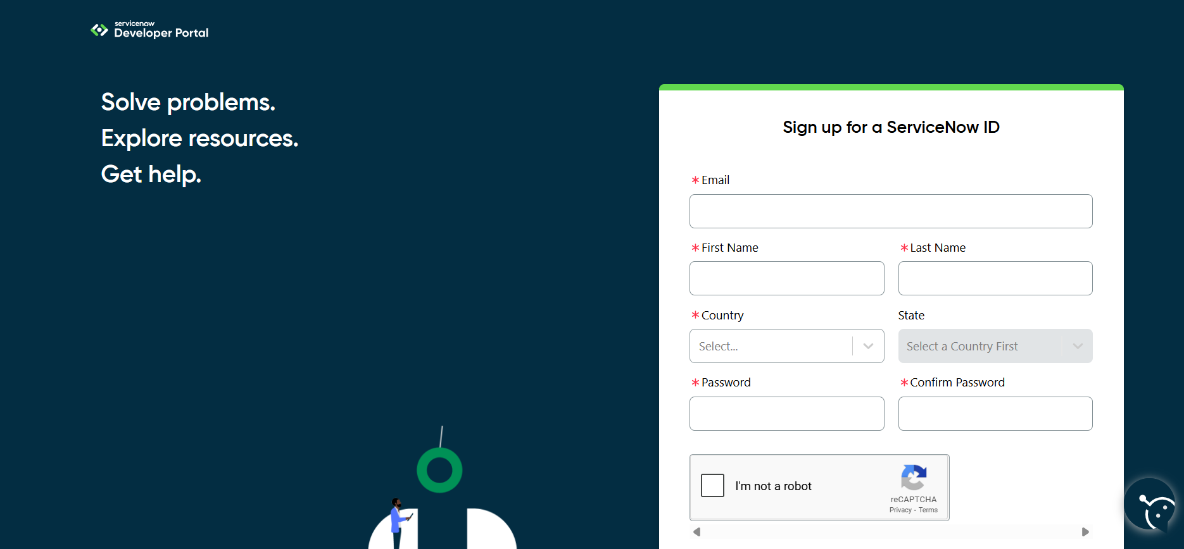

After signing up you will get an verification mail to you provided email id. After the verification your ServiceNow Developer Portal Home Page will appear

Now click on start building it will take you to the section where you can **request a Personal Developer Instance (PDI)** or start using **App Engine Studio** and other tools.

**Profile Icon (Top Right Corner)** → Manage your account, request instances, and check your developer profile.

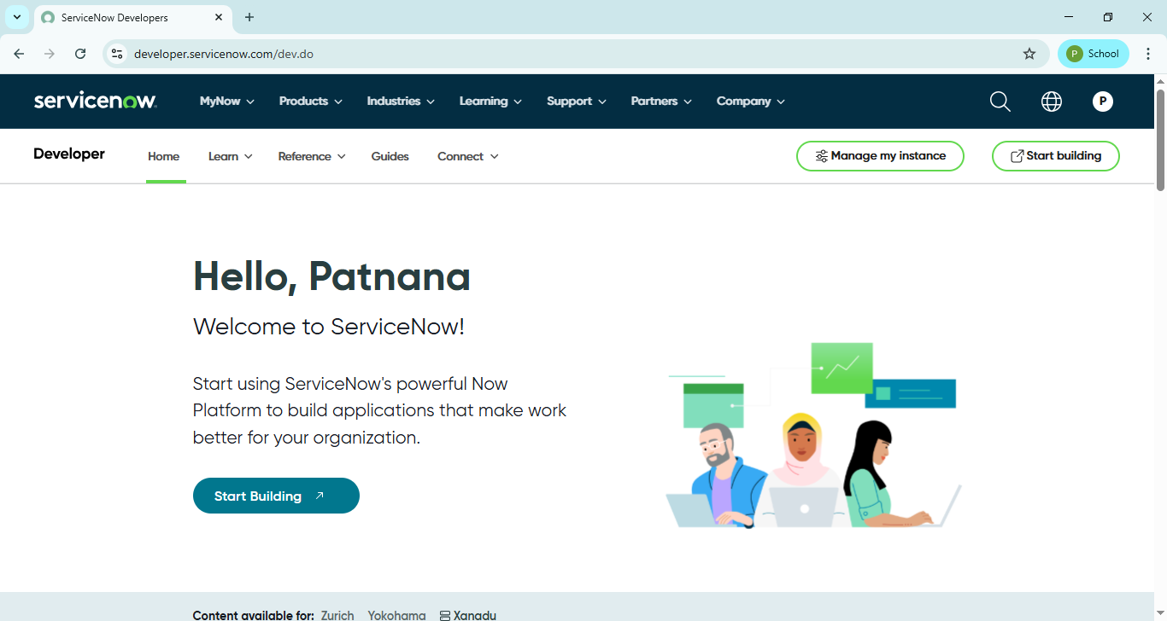

## **5. Project Implementation in ServiceNow:**

After the instance building is completed the page will be directed to your creator studio.

Creator Studio in ServiceNow provides a **guided, no-code environment** to build applications quickly. It is especially useful for creating **request-based applications** by defining forms, setting up tables, and automating workflows.

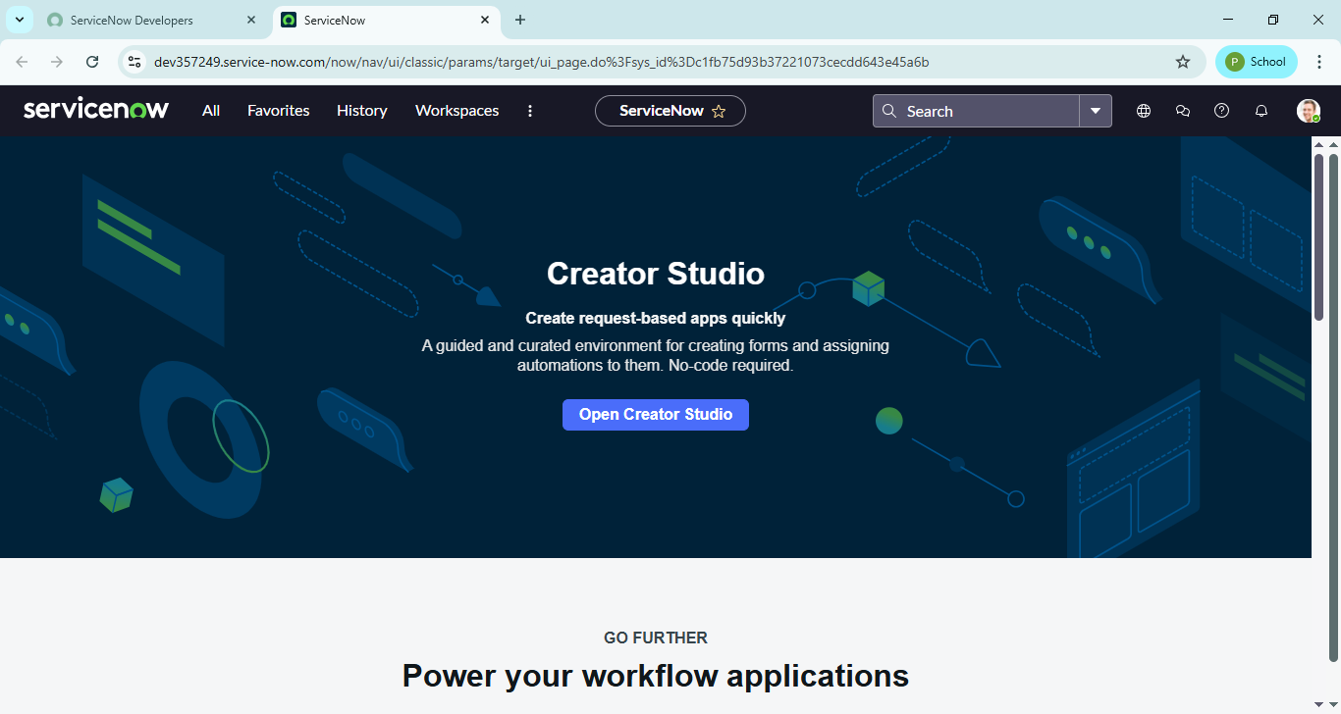

**a.Creation of Local Update set**

Steps to create local update set in ServiceNow:

1.Open service now.

2.Click on All 🡪 search for update sets

3.Select local update sets under system update sets

4.Click on new

5.Fill the following details to create a update set as: “Laptop Request”

6.Click on submit and make current

7.By clicking on the button it activates the update set .

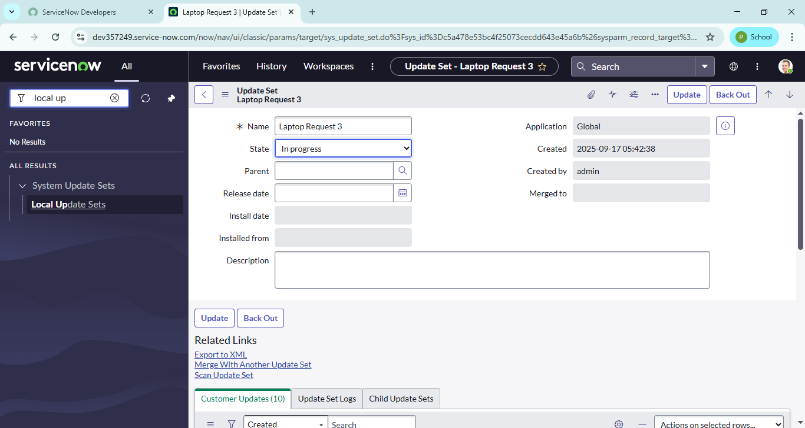

**b.Service Catalog Item**

**b.1.** **Create Service Catalog Item:**

Steps to create Service Catalog item in ServiceNow:

1.Open service now.

2.Click on All  🡪 service catalog

3.Select maintain items under catalog definitions

4.Click on New.

5.Fill the following details to create a new catalog item

            Name: Laptop Request

            Catalog: service Catalog

            Category: Hardware

            Short Description: Use this item to request a new laptop

6.Click on ‘SAVE’

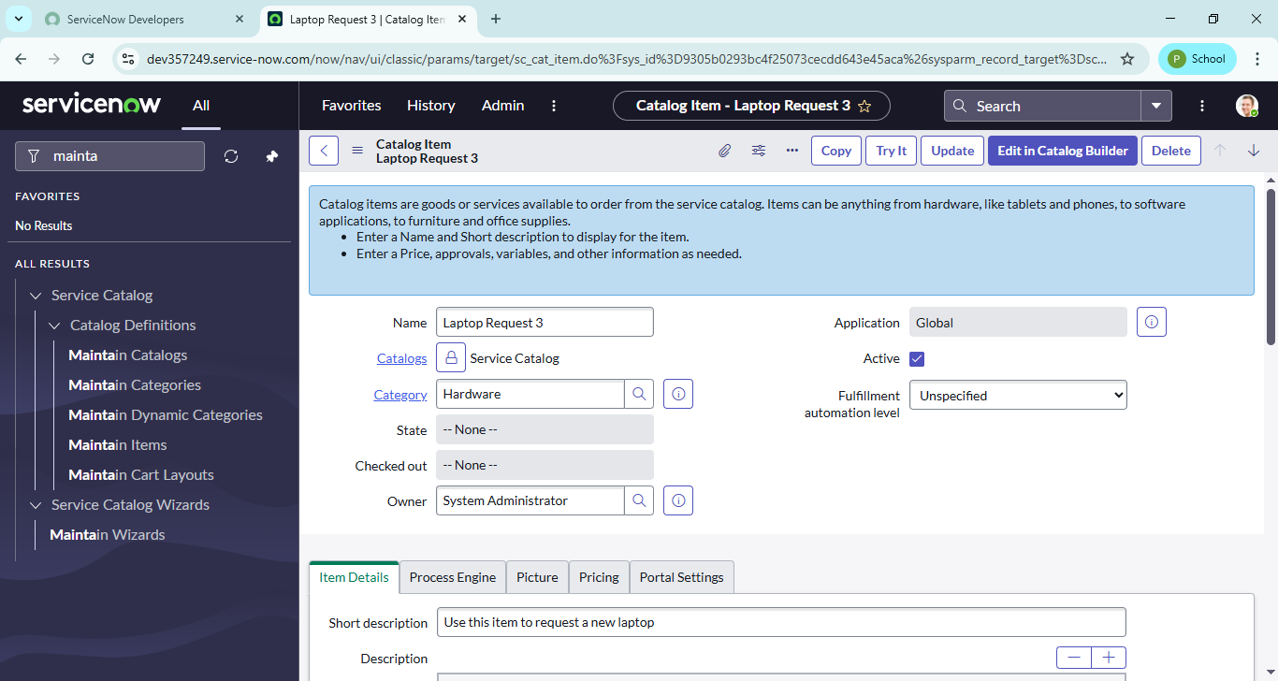

**3.2.Add variables:**

Steps to add variables:

**Step1:**

* After saving the catalog item form scroll down and click on variable(related list)
* Click on new and enter the details as below

1. Variable 1:Laptop Model

             Type: Single line text

             Name: laptop_model

             Order:100

* Click on submit
* Again click on new and add Remaining variables in the above process

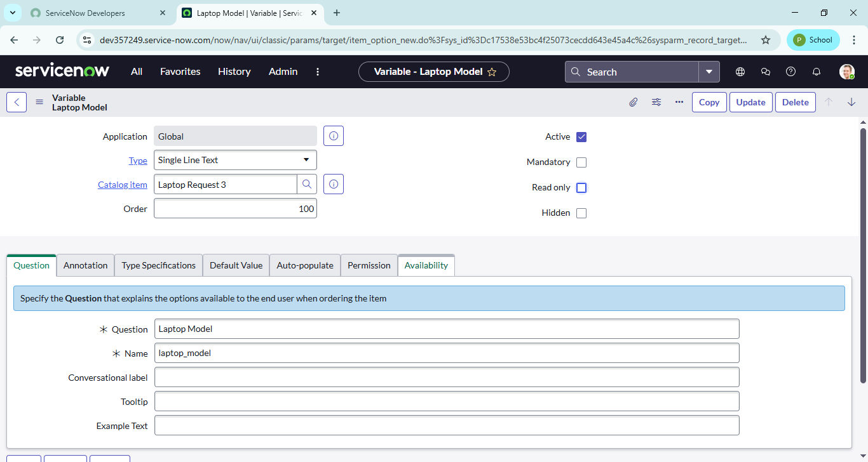

2. Variable 2:Justification

             Type: Multi line text

             Name: justification

             Order:200

     3. Variable 3:Additional Accessories

             Type: Checkbox

             Name: additional_accessories

             Order:300

     4. Variable 4: Accessories Details

             Type: Multi line text

             Name:accessories_details

             Order:400

**Step2:**

* After adding above variable which are added to newly created catalog item
* Then save the catalog item form

## 

**c.** **Create Catalog Ui policies**

Steps to create catalog Ui Policies:

1.Click on all🡪 search for service catalog

2.Select maintain item under catalog definition

3.Search for ‘laptop request’ which is created before

4.Select ‘laptop request’ and scroll down click on “Catalog Ui policies”

5.In the catalog ui policies related list tab click on new

6.Give short description as: show accessories details

7.Set the Catalog Condition in the related list tab ‘when to apply’

                  [field: additional_ accessories, operator: is, value: true]

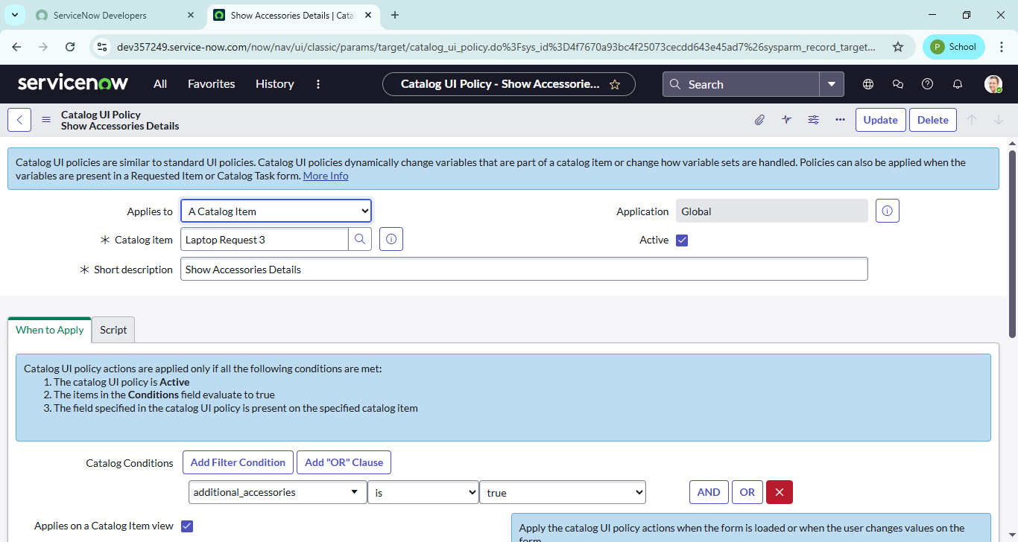

8.Click on **save**.(do not click on submit)

9.Scroll down and select ‘catalog ui action’

10.Then click on new button

11.Select variable name as: accessories_details

                              Order:100

                    Mandatory: True

                         Visible : True

12.Click on save and again click save button of the catalog ui policy form

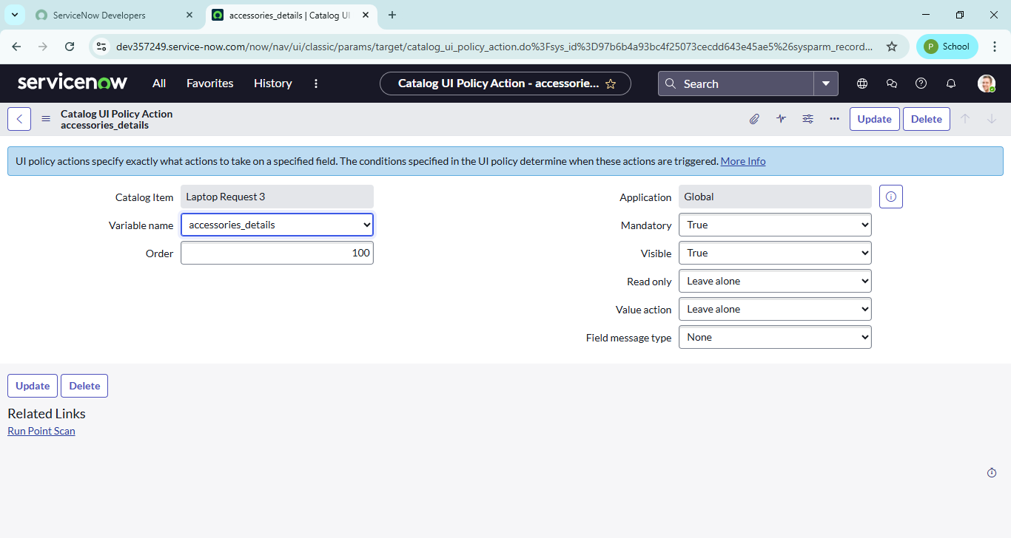

**d. Creation of ui action**

1.Open service now.

2.Click on All  >> search for ui action

3.Select ui actions under system definition

4.Click on new

5.Fill the following details to create ui action

              Table: shopping cart(sc_cart)  
              Order:100  
              Action name:  Reset form  
               Client : checked  
Script:  
    function resetForm() {  
    g_form.clearForm(); // Clears all fields in the form  
    alert("The form has been reset.");  
}  
  
Click on save

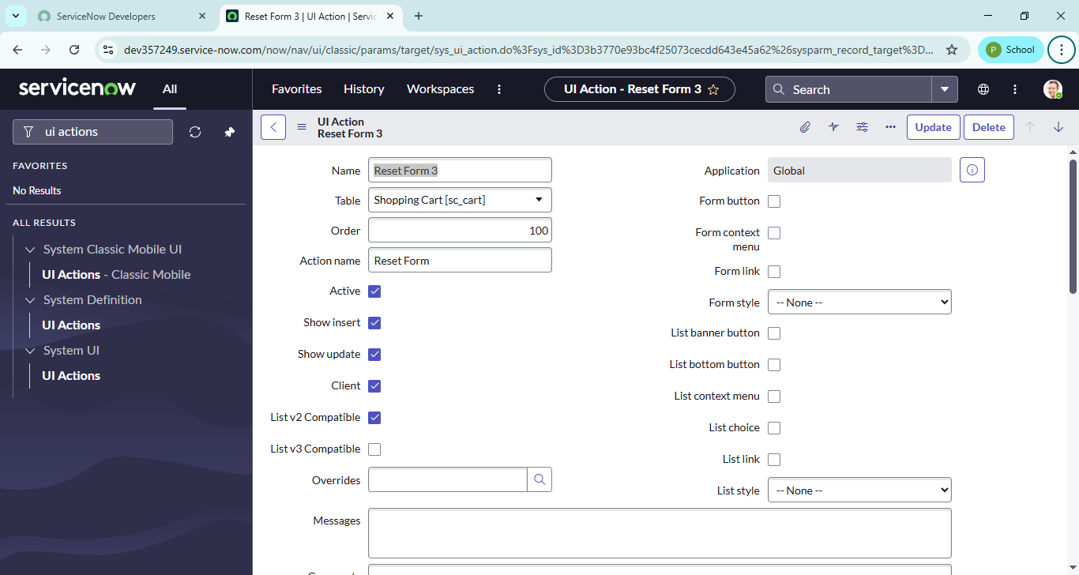

**e. Login to another Instance**

Steps to Export changes to another instance:

1.Click on All  >> search for update sets

2.Select local update set

3.Select created update set i.e. ‘Laptop Request Project’

4.Set the state to ‘Complete’

5.In the related list Update tab, updates are visible which we perform under this update set.

6.Click on export to XML ,it download one file

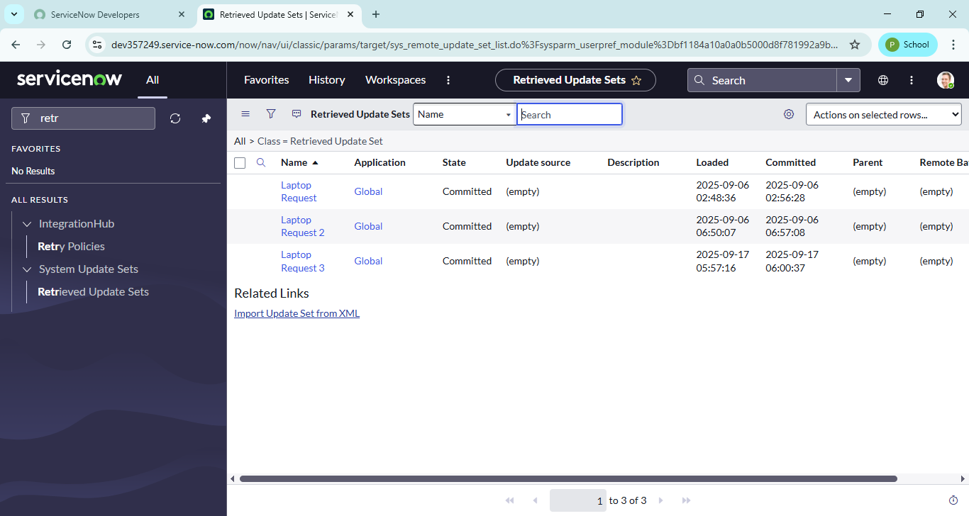

7.Upload the downloaded file in XML file

8.Click on Upload and it gets uploaded.

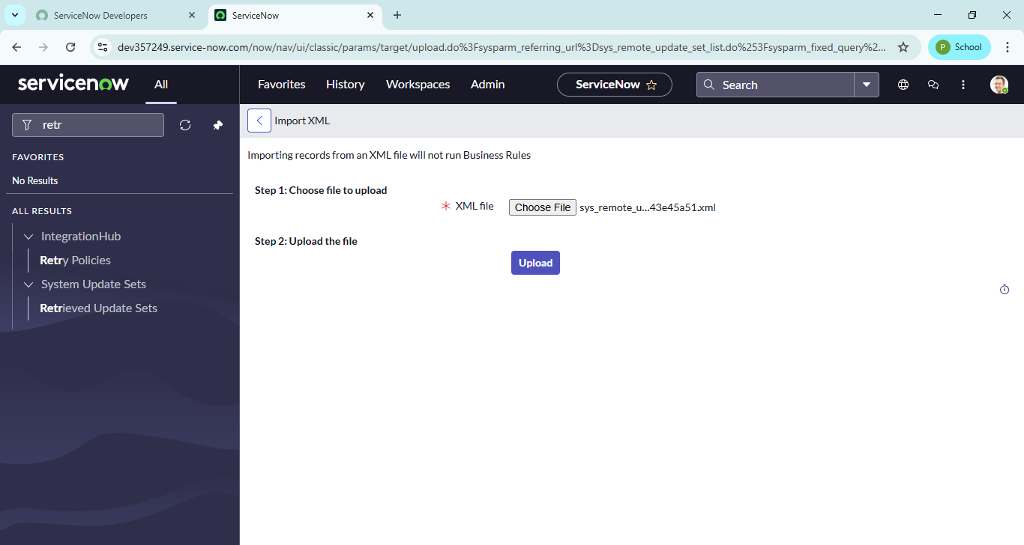

9.Open retrieved update set ‘laptop request project’

10.Click on preview update set

11.And click on commit update set

12.And also see the related tab updates

13.After commiting update set in this instance we get all updates which are done in the previous instance.

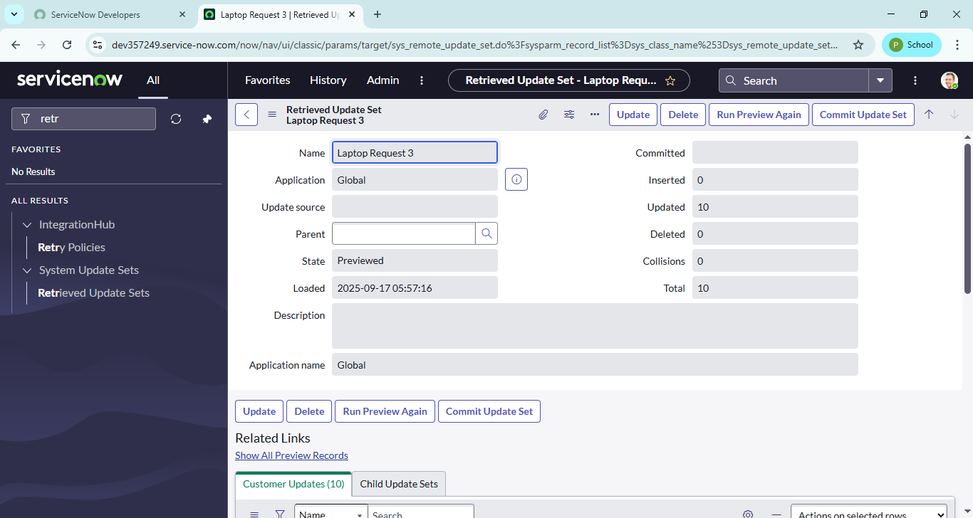

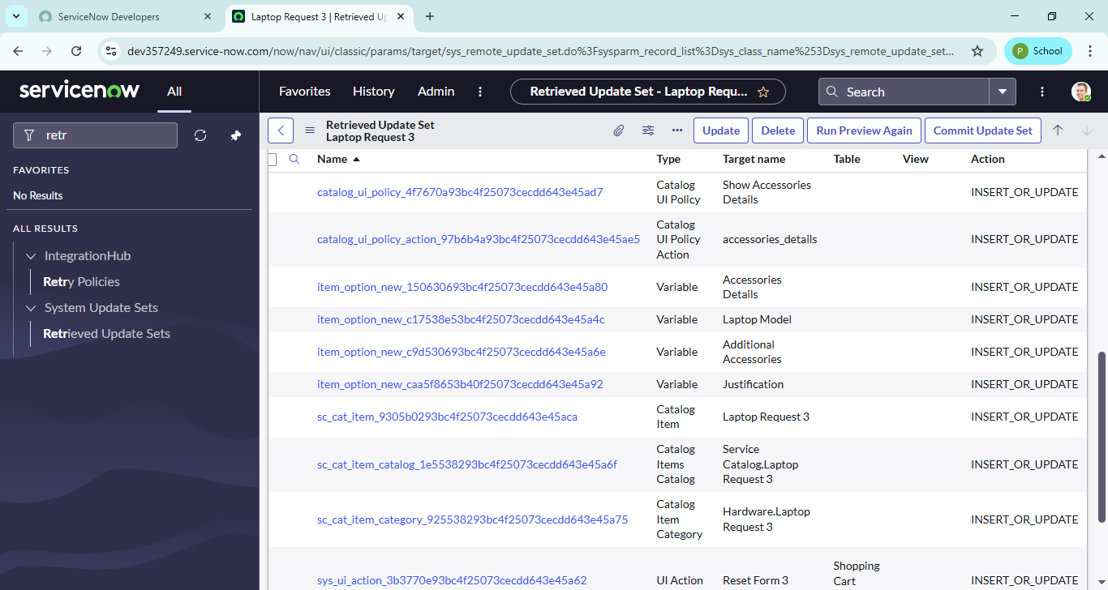

## **6. Screenshots of Output:**

After implementing the Maintain Item in ServiceNow and exporting xml file, test the catalog item.

1.Search for service catalog in application navigator in target instance

2.Select catalog under service catalog

3.Select  hardware category and search for ‘laptop request’ item

4.Select laptop request item and open  it

5.It shows three variables only

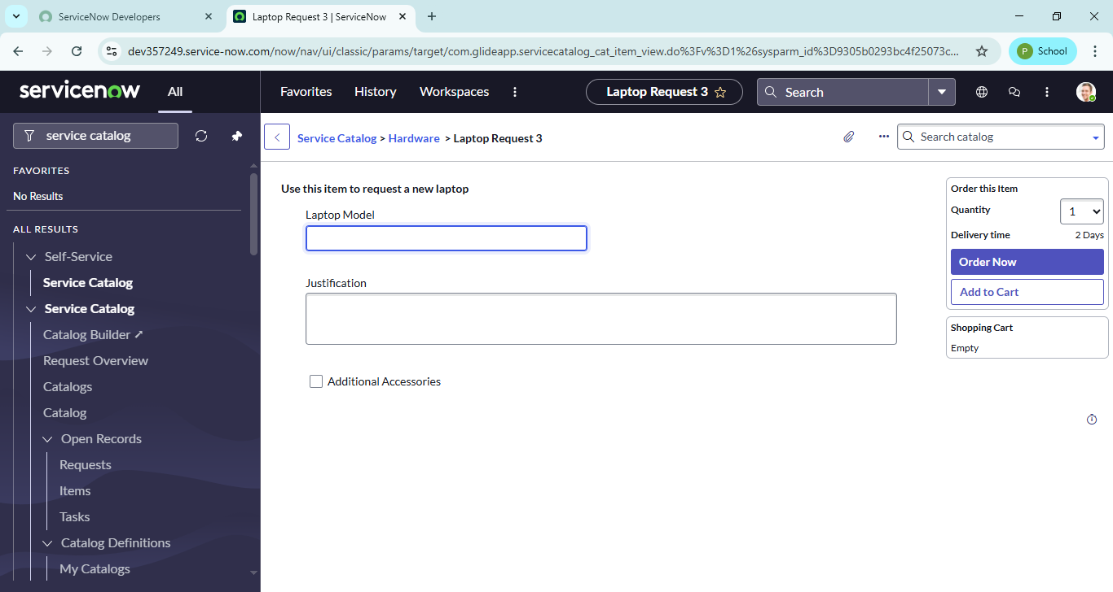

6.As per our scenario, when we click on additional accessories checkbox then accessories details fields is visible and that should be mandatory

7.Now  see the results,it fulfills our requirements.

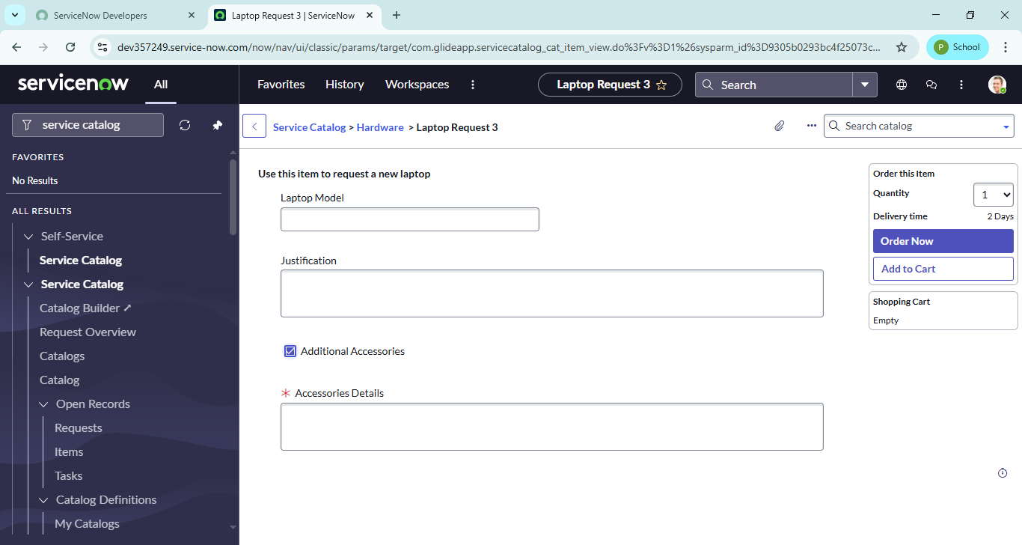

## **7. Conclusion:**

The implementation of the **Laptop Request Catalog Item** in ServiceNow has streamlined the process of requesting laptops at ABC Corporation. By leveraging ServiceNow’s Service Catalog capabilities, employees now have access to a dynamic, user-friendly, and guided request form that ensures accuracy and efficiency. This eliminates manual errors, reduces delays, and provides IT teams with the right information upfront to fulfill requests quickly.

With the setup of catalog variables, dynamic rules, workflows, notifications, and governance tracking, the request process is now:

* **Faster** – Employees can submit requests in minutes with guided forms.
* **Accurate** – Dynamic fields ensure complete and correct information.
* **Efficient** – Automated workflows streamline request handling for IT.
* **Employee-focused** – A modern interface improves satisfaction and request transparency.

In summary, this project demonstrates how ServiceNow can be used to replace manual, error-prone processes with automated, efficient, and employee-centric solutions. It not only improves IT service delivery but also enhances employee productivity by providing timely access to essential equipment.